

NOTICE TO MARINERS
PETERHEAD PORT AUTHORITY

Bathymetric Data

NOTICE IS HERBY GIVEN, that following a survey of the whole port, the latest Bathymetric Data is now available to download from:
Notices to Mariners | Peterhead Port Authority
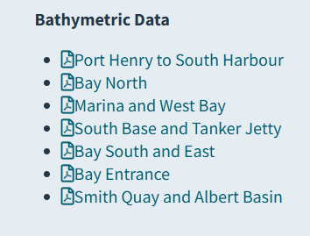
PPA would strongly encourage all mariners navigating in the port to download and incorporate the data as part of their passage plan.

Cpt Ewan Rattray
Harbour Master & Director of Port Operations
22nd Sep 2025

