

NOTICE TO MARINERS
PETERHEAD PORT AUTHORITY
Mitchells Quay Repair Works

Notice is hereby given, that as of 6th April 2026, Mitchells Quay will be unavailable for working nets due to repairs works being carried out to the face of the quay.
Works will be carried out in line with the below diagrams.
Alternative piers will be available during this period such as the box berth and albert quay.

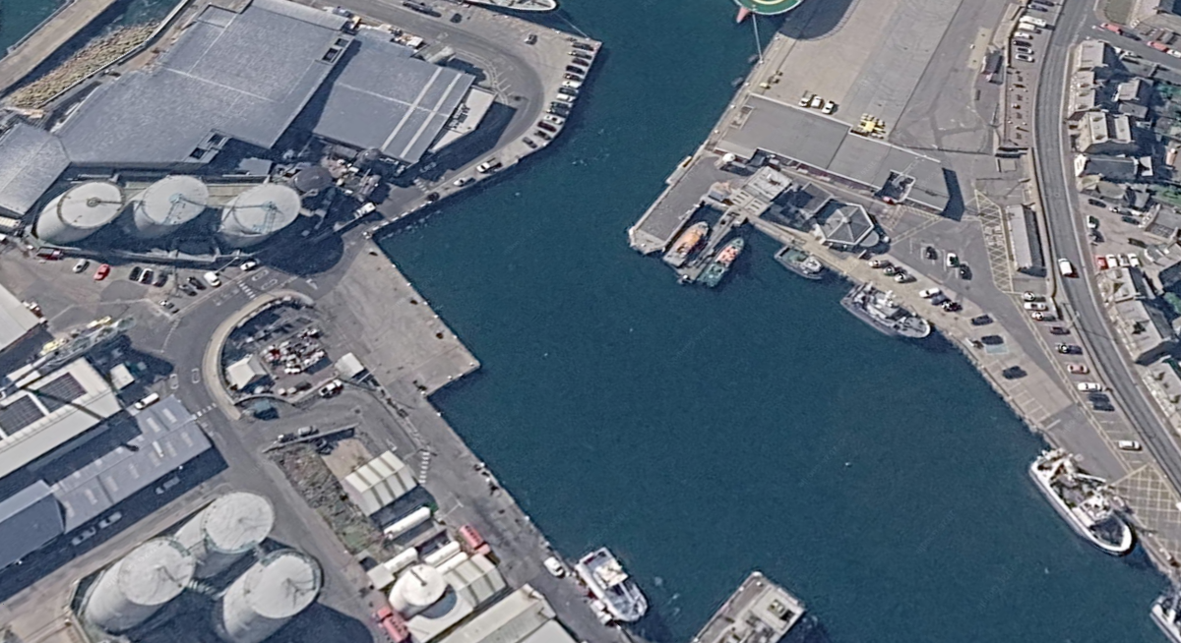
Mitchells Quay
Concrete Repairs

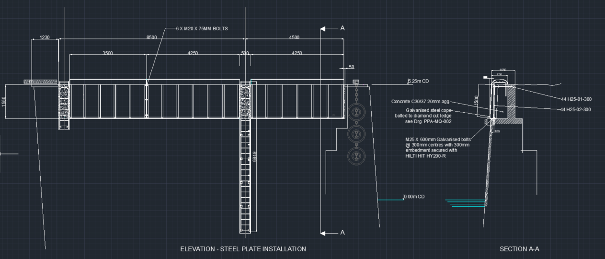

We appreciate your patience with this matter.

Marine Department
9th January 2026

